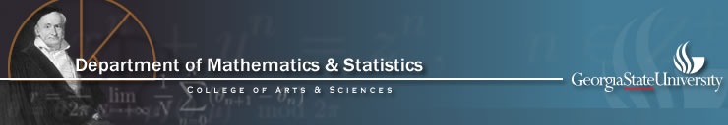

End-of-Semester Celebration of Mathematics and Statistics

Organized by the Mathematics and Statistics Club at Georgia State

Friday April 9, 11:00-1:00 pm, 796 COE (light lunch will be provided)

RIMMES presentations (11:00-12:45 pm):

11:00pm-11:10 pm
India Jackson: Students' abilities and strategies in interpreting information from mathematical textbooks Mentor: Dr. Draga Vidakovic

11:15-11:25pm
Diarra Weir: Students' utilization of the available aids in self-regulated learning in the MILE Mentor: Dr. Draga Vidakovic

11:30-11:40 pm
David Clifton: Synchronizability of Dynamical Networks Mentor: Dr. Igor Belykh

11:45-11:55pm
Tan Tran: Grobner bases, toric ideals and integer programming: an applications to economics Mentor: Dr. Mariana Montiel

12:00-12:10pm
Neal Aronson: Aspects of divisibility in Frobenius skew-polynomial rings
Mentor: Dr. Florian Enescu

12:15-12:25pm
Gregory Rehm: Applications of solving ill posed problems in geology
Mentor: Dr. Alexandra Smirnova
12:30-12:40pm
Thomas Polstra: On the integral formulas of Green, Cauchy, and Pompeiu
Mentor: Dr. Imre Patyi
Presentation of Student Awards ( 12:45-1:00pm)

The Calculus Undergraduate Awards, the Math Award and the winners of the Sixth Annual Undergraduate Mathematics Competition.

ALL STUDENTS AND FACULTY ARE INVITED TO ATTEND!

